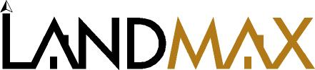 www.Landmaxdata.com

Greater Binghamton Association DISCOUNT - tax map options

Counties available :
- Broome (available in paper atlas and CD-Rom)
- Chemung, Cortland, Delaware, Madison, Otsego, Schuyler, Tioga ,Tompkins (CD only)

CHECK BELOW

* Broome and Tioga County (CD format) ………………………..…$ 129.00 ------------
* Broome Paper Atlas (incl. Broome/Tioga CD)…………………..…….....$ 325.00 ------------
* Chemung, Cortland, Delaware, Madison, Otsego, Schuyler, Tioga , Tompkins
CD format can be added for $ 45.00 each ------------
* All 9 counties CD format would total $ 399.00 ------------

@ Prices reflect an annual lease cost subject to NYS sales tax and to be maintained on a separate contract with Landmax

COMPANY NAME______________________________________________________________
ADDRESS_____________________________________________________________________
TOWN,CITY,ZIP________________________________________________________________
PHONE /EMAIL ( )____________________ / _____________________________________
SIGNATURE_________________________________Print______________________________

You can mail/fax/email the completed form back to us at:

Michael West
Landmax Data Systems, Inc.
5919 E. Henrietta Rd.
Rush, NY 14543
ph. (585) 533-9210
fx. (585) 533-1012
email: support@landmaxdata.com

